
Effective Marking
Policy and Teachers Guide
2013-2014

Imagine what a difference it would make if all children knew what they were good at and knew what they needed to do to improve

Contents
Page

Introduction and Rationale ……………………………………………………... 3

Marking Strategy (Formative marking)………………………………………... 4-7

Strategy summary and frequency table ………………………………………. 8

What the strategy looks like

- Acknowledgement marking………………………………………........... 9

- Quality teacher marking……………………………………………….. 10

- Quality student marking (Peer and Self assessment)…………………...11

- Verbal feedback……………………………...………………………….. 12

- Directed Improvement and Reflection Time………………………….. 13

Success criteria book scrutiny table…………………………………………… 14-15
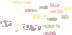
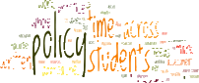

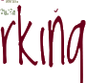

Foreword

Marking student’s work is the core part of working life for any teacher and it can seem endless, stretching well into our evenings and weekends. With all the other things a teacher is expected to do, the question is simple, does it make any difference and is it worth the time and effort?
THE ANSWER IS A RESOUNDING YES!

I believe effective feedback is a crucial component of Assessment for Learning. It is when we can really show children that we value their efforts, it is when we can judge our own effectiveness as teachers, it is when we can make strategic decisions about the next steps children need to make. But more than all that, it is a rare opportunity to have an

individual dialogue with every child
because every child matters and
always will.

Regular selective and effective marking is crucial to our student’s progress. Formative marking is key, focusing on what is going well and what specifically needs to be done to improve, linked to success criteria.

The next step is to make sure that we act on these comments. If you are going to take the time to write comments, then you need to build in adequate time for students to respond them. Otherwise your marking is a waste of time! Directed Improvement and Reflection Time gives the students opportunity to reflect on their targets and improve their work, leading naturally to improvement in attainment.
This strategy aims to address the work-life balance whilst also effectively providing students with the feedback they need to make
“outstanding progress’’
Rachael E

SRS Marking Strategy (Formative marking)
There are four main types of written feedback that teachers can use and students can expect to see or also use. Outlined later in this policy is the agreed minimum regarding the frequency of each type of feedback.
- Acknowledgement marking- checking that the work has been completed and that there are no obvious mistakes that need correcting.

- Quality teacher marking- Feedback and Feedforward

- Directed Improvement and Reflection Time (D.I.R.T)

- Quality marking by students- Peer and Self assessment


- Acknowledgment marking.
Light touch/“tick and flick”/checking marking – in order to support the giving of quality feedback at key points in the learning process, other work should be marked in less detail. Light touch marking will develop the skills of peer and self assessment, and will stand along side whole class and teacher led marking of more closed tasks, class notes and exercises. Teachers will acknowledge such work variously through the use of an effort grade, ticks, simple marks or corrections (10/10)
and/or brief attainment based comments.
- Quality Teacher marking.
FB

FF
Much research has shown that grades/scores or grades/scores and a comment do not raise standards. Developmental comments alone raise standards as they help pupils to understand the main purposes of their learning and thereby grasp what they need to do to improve. However it will be necessary on key pieces of work to provide a level/grade e.g. summative assessment.
Quality marking should use the “Feedback/Feedforward” framework or FB/FF. It should be laid out at the end of the piece of work as follows:
FB- positive comment which relates to the learning objectives /success criteria
FF- Area where the success criteria was not met / or a suggestion /question to encourage further thinking.
The strengths and next steps should relate to the success criteria set for the piece of work given.
- Quality Student Reflection (DIRT)
We never truly learn anything till we reflect. Reflection time for students will be built into the school calendar and the expectation is that D.I.R.T is carried out prior to the 5 main assessment data points in the year. Students produce an assessed piece of work, the work is quality marked by the teacher
- Peer/ Self Assessment
Students could be trained to use the SSW system against clear and agreed success criteria. Opportunities should be built into the scheme of work to allow for peer and self assessment. This should allow students to gain a better understanding of where they are, where you need to be and what they need to do to improve

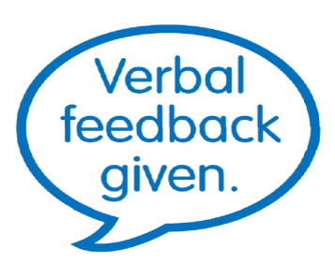
Verbal feedback. (Formative feedback)

Verbal feedback is a valuable form of formative feedback. Some may use this type of feedback more frequently because of the nature of their subject. For example in Design and Technology, art, music and physical education the most effective feedback is often verbal. It involves frequent use of open and probing questions and an ongoing dialogue as work progresses towards the learning intention/success criteria.

In written subjects such as English, Humanities, Maths etc verbal feedback may be identified as having taken place using a stamp’ or via writing ‘VF’, the date and signing the students copy book.

Marking for literacy

In an E.A.L school such as SRS it is clearly essential that we all take responsibility for correcting and attempting to improve our student’s literacy skills.

You will not expect to mark/correct every punctuation and grammatical error in every piece of writing. Neither will every spelling mistake need to be corrected. NB: Some subjects may correct spellings that are subject specific rather than all spelling errors

Pupil involvement
You may ask students to check through their work to look for any obvious spelling, punctuation or grammatical mistakes and correct them or highlight them using the marking for literacy codes which are displayed below and will also be found in their planner.

SRS Correction Code- Marking for Literacy

Sp : Underline incorrect spelling
(In margin instruct student to practice
correction three times e.g. spx3)

O : Punctuation is incorrect

P : Punctuation mark is missing

T : Verb tense is incorrect

exp : Expression needs correcting (underline)

^ : To indicate a missing word or letter

- : A correct feature/ aspect

// : To indicate a new paragraph is needed

Literacy is tackled using the whole school literacy codes and correcting subject specific spellings.

In outstanding examples students have been given the time to look back at the codes and correct their work.

Monitoring and Evaluation
The monitoring of this policy will be the responsibility of the MLT/SLT. Subject leaders must ensure their Dept marking policy supports the school marking and assessment policy.
Subject leaders undertake the work sampling of their subject in accordance with the whole school self evaluation cycle/ RESI. SLT will oversee the above process and provide opportunities for middle leaders to share and discuss practice. The findings will be fed back to staff with suggested areas for improvement.

Policy Review
This policy will be reviewed annually by all staff and changes will be made to ensure that this policy reflects best practice and is up to date.



Summary of Marking Policy- SRS Formative written and verbal feedback


 | Type of  marking. | Stamp/ Symbol  associated | What it looks like. | Frequency
1 | Acknowledgement and checking |  | Work has been checked for completion and correctness. (Simple checking and where necessary correcting mistakes) Teachers will acknowledge such work through the use of ticks, simple marks (10/10) or corrections and/or brief attainment based comments. A stamp could also be used. | Every piece of work should be acknowledged
2 | Quality teacher  marking/  written feedback | FB  FF  ` | Feedback/ Feedforward.  This is detailed feedback which relates to how well students have met the learning objectives in classwork and homework. It gives them the next step in improving their work.  FB- positive comments which relates to the learning objectives /success criteria  FF- Area where the success criteria was not met / or a suggestion /question to encourage further thinking.  Pupils should have the opportunity to respond to the FF. | At least 5 times per term.  (Approx every 2 weeks)
3 | Directed Improvement and Reflection Time | D.I.R.T | Students reflect on the above quality teacher feedback. They respond to the target given and redraft their work, the teacher then re marks and awards final level/ grade. | At least 6 times per academic year. (prior to data entry)
4 | Quality marking  by the students |  | Opportunities should be built into the scheme of work to allow for peer and self assessment.  FB/FF. As above but done by students with support from clear criteria from the teacher. This should allow students to gain a better understanding of where they are, where you need to be and what they need to do to get there. | At least twice per term. This may be done orally in practical subjects.
5 | Verbal feedback | 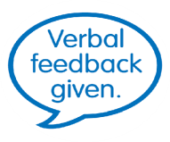  VF | There should be opportunities for effective verbal feedback. It involves frequent use of open  and probing questions and an ongoing dialogue as work progresses towards the learning intention/success criteria.  This may be identified on work using a stamp or a ‘VF’ followed by the date and teacher’s signature. | Use as appropriate to support other forms of feedback

Acknowledgement marking

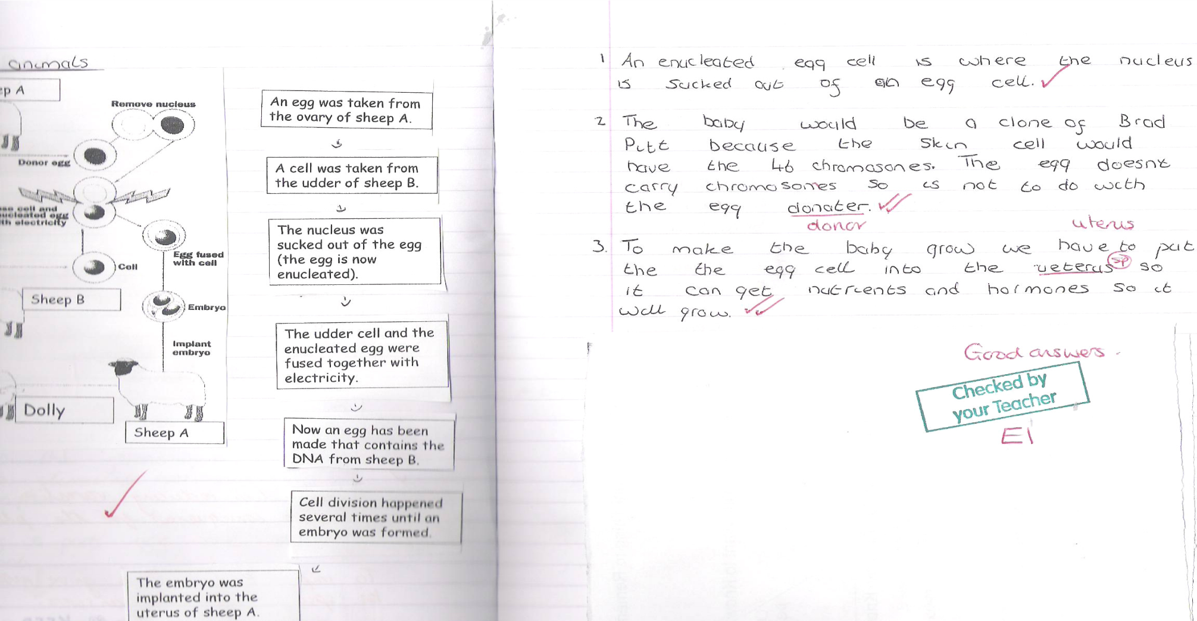

At its simplest a checked stamp or tick will appear to acknowledge that the work has been satisfactorily completed by the student. There may also be simple corrections, marking for literacy or simple comments/questions/targets

Outstanding practice will see errors more thoroughly checked in some pieces of work.

Quality teacher marking

Example 1: Science example, student responds to the target
as part of the starter for the next lesson. The student’s comment is in green

At its simplest the FB/FF allows staff to focus on the positives and suggest an area for improvement. In best practice around school the comments should be directly related to objectives

/success criteria.

Outstanding feedback would also include clear evidence

of students responding to the targets/questions/FF.

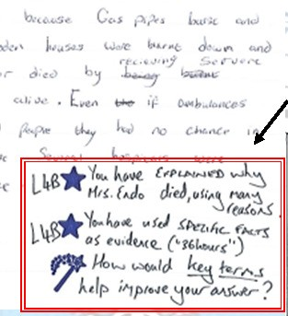
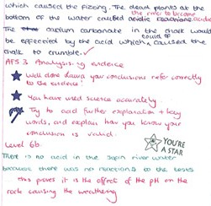

Example 2: Humanities example, teacher poses a question as a target to encourage a response

Quality Student Marking
In some outstanding examples it is clear that students are being trained to use the SSW system against clear and agreed success criteria.

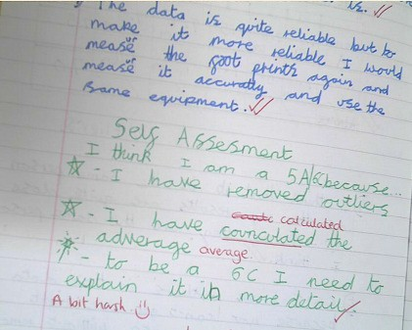

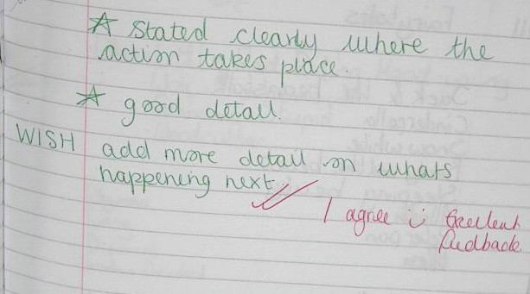

Example 1: Science linked to APP criteria in lesson (Year 7)

Example 2: English (Year 9)

Verbal feedback (Recording it has happened) Often it is difficult to evidence when verbal feedback has happened in a lesson. Where verbal feedback has been

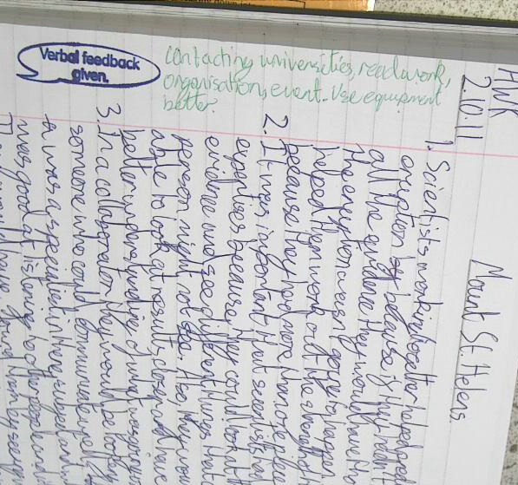
given in the lesson, this may be acknowledged using a feedback stamp or ‘VF’ signed by the teacher. In outstanding examples it should be clear that students have acted upon the advice.

The example on the left was verbal feedback given for a homework piece. All students had made a similar error, rather than writing this correction on all students work, this formed the starter for the next lesson. Students recorded the feedback next to the stamp.

Directed Improvement and Reflection Time (D.I.R.T)

What the strategy looks like?

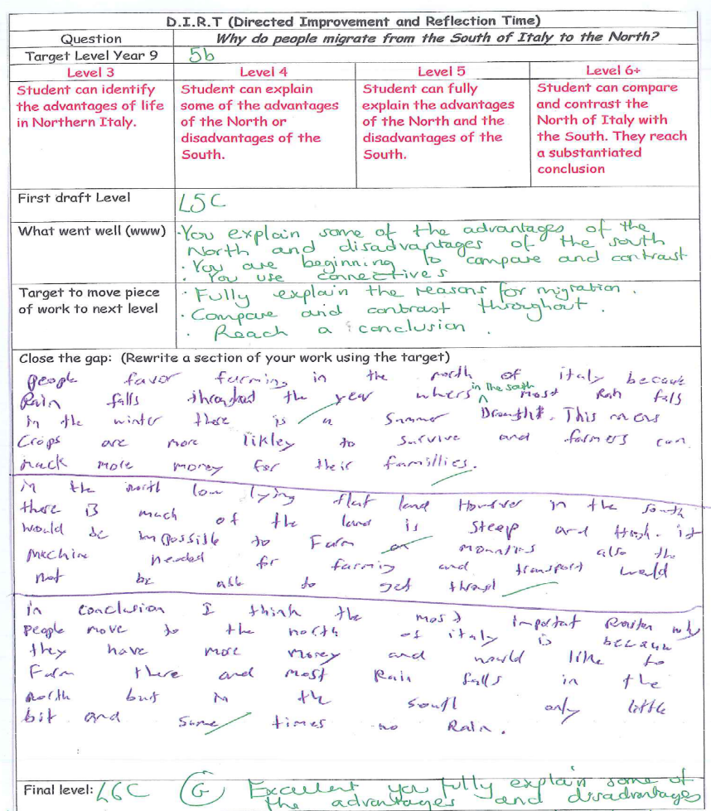
Following an assessed piece of work, students work on ‘closing the gap’. They are given the opportunity to improve the work based on the teacher’s target.
Teacher | Name of student | Year | Data |  |  | Presentation (e.g. neat work, use a ruler) | Acknowledgement comment (e.g. ticks) | Isolated Praise (e.g. excellent or good effort) | Comment about completion of work (where is your hwk) | Marking for literacy | Specific comment linked to subject learning/L.O) | Evidence of quality teacher feedback (FB/FF) | Evidence that students are addressing feedback (DIRT) | Evidence of peer/self assessment | Verbal feedback is given | Additional comments
Teacher | Name of student | Year | KS2 | KS3  Target | Current level

Teacher | Name of student | Year | Data |  |  | Presentation (e.g. neat work, use a ruler) | Acknowledgement comment (e.g. ticks) | Isolated Praise (e.g. excellent or good effort) | Comment about completion of work (where is your hwk) | Marking for literacy | Specific comment linked to subject learning/L.O) | Evidence of quality teacher feedback (FB/FF) | Evidence that students are addressing feedback (DIRT) | Evidence of peer/self assessment | Verbal feedback is given | Additional comments
Teacher | Name of student | Year | KS3 | KS4  Target | Current Grade

