Presents
Dubai Lead Meet

Tuesday 1st March 2016
4pm-6pm
Blue room,
Dubai World Trade Centre

Sponsored by:
GESS Education
E Teach International
Qaisar Zahoor
Pearson

Pobble

Twinkl







Rachael Edgar-Host
Dubai English Speaking College
Lead co-ordinator SPARK

Rachael’s career in education spans over 16 years and includes posts in schools, both in the UK and the UAE. She has held a variety of leadership roles, to include Advanced Skills Teacher (Teaching and Learning) and Assistant Head Teacher for Teaching and Learning. Passionate about CPD and educational research, she is interested in promoting cross institution pedagogic collaboration as part of professional development and in promoting and developing ways to support educators, to share the best evidence available and improve their teaching practice.
It was social media that first brought Rachael to SPARK (Sharing Pedagogy and Refining Knowledge) in 2013 and she took over the role of lead co-ordinator in September 2014. In the last three years SPARK have held 16 large Teach Meets at schools across the Middle East, to include events in Dubai, Abu Dhabi, Sharjah, Al Ain, Doha and Bahrain. SPARK continues to thrive and grow in popularity amongst the teaching community; there are several additional events in the pipeline for this academic year. Leading SPARK has meant Rachael is constantly in awe of the generosity of other educators and willingness to share their ideas. She is delighted to be hosting her second leadership focused event at GESS.

See the website www.sparkevent.me for more details.
@Dubai_Teachmeet @SPARKEducators
Rachael@sparkevent.me I www.Dubai-Teachmeet.com

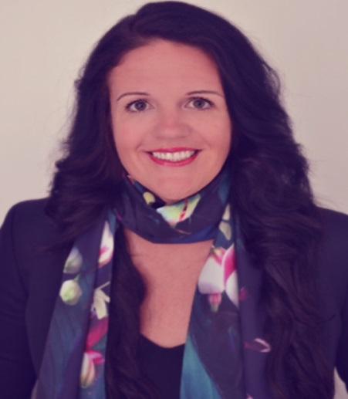

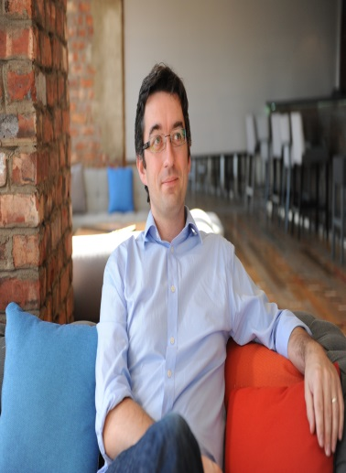
Ewan McIntosh- Opening keynote
Managing Director No Tosh Ltd

Ewan McIntosh and his team at NoTosh are award-winning educators who work with schools and universities to create inspiring learning experiences that get results. The team, based in Scotland, Australia and San Francisco, has a global reputation for researching and delivering new learning opportunities for schools, but also some of the world’s top creative, tech and engineering companies.

@ewanmcintosh
info@notosh.com

Stephen Green-Presenter
Dubai English Speaking College
Assistant Head Teacher

Stephen graduated from Leicester University with an honours degree in History and Archaeology (2:1), before embarking upon a PGCE at Nottingham University. After successfully completing this course he worked in Nottingham for two years, having being promoted after one year to head of department.
He moved with his wife, Sian (now Head of Desert House at DESC) to Doha, Qatar where they worked for eight years. In that time Stephen was promoted first to Head of History, then Curriculum Leader and finally Head of Sixth Form. It was during this time that he successfully completed and passed his NPQH. He then spent two immensely enjoyable years at Derby High School, a leading independent school in the UK, before being promoted to Head of Secondary at Kings College, Alicante in Spain.
Stephen joined DESC as Assistant Head teacher in September 2012. He is responsible for Assessment and Curriculum, Achievement Partnerships, ECAs and is also a teacher of History.

@descdubai
www.descdubai.com

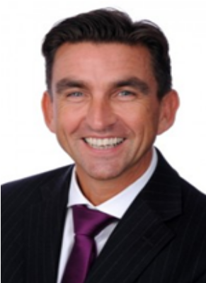

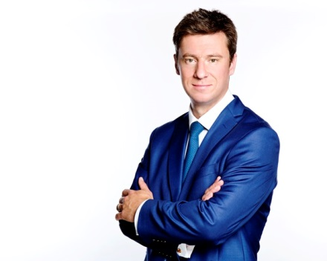
Michael Lambert- Presenter
Dubai College
Headmaster

Michael Lambert has been Headmaster of Dubai College since the beginning of September 2015. Formerly Assistant Head responsible for Sixth Form, Careers and Academic Guidance, he was educated at the universities of Oxford and SOAS where he studied Classics and Anthropology. He was formerly Product Development Manager at Barclays Stockbrokers before starting his teaching career at the Royal Grammar School, Guildford. For the last four years he has taught Classical Civilisation and Latin at Dubai College after introducing these subjects to the school’s curriculum and is also an examiner of Latin for the OCR exam board. He is a qualified NLP practitioner and has a Postgraduate Diploma in psychotherapy and counselling.
@DubaiCollege
www.dubaicollege.org

Jim Stearns- Presenter
Victoria International School Sharjah
Deputy principal/ Headteacher Secondary

Jim has been Deputy Principal and Head of Secondary School at VISS since August 2014. Jim has taught in a number of UK state and independent schools in his 20+ year career, including over five years as Headmaster of Shoreham College, an all-through primary and secondary school near Brighton, England. A trained physics teacher, Jim has also specialised in the use of IT in education, serving on national advisory committees, writing articles and speaking at conferences on this and other topics. During his UK headship he has been an active member of the Independent Schools’ Association (ISA) serving on the national executive and chairing its Academic Policy Committee through a period of extensive curriculum change in the UK. Since arriving at VISS, he has also qualified as an Apple Education Trainer.

@tallheadmaster
www.viss.ae

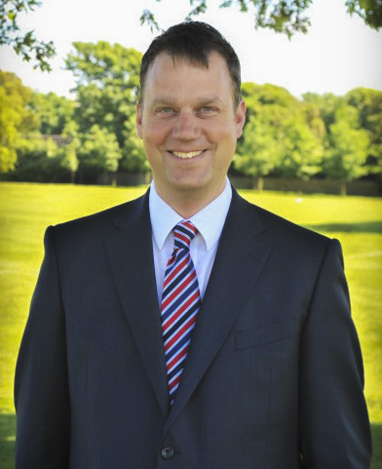

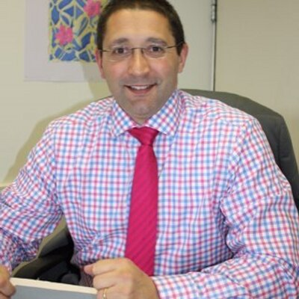
Harvey Trump- Presenter
Regent International School
Head teacher of Secondary

Prior to taking up his role as Head of Secondary at Regent International School, Harvey’s first headship at St. Dominic's Brewood in the UK was to develop the strategic aspects throughout school, develop the Sixth From and introduce boys into the primary department of this girl’s only school. Previously Harvey was a professional cricketer for ten years at Somerset CCC and went on to become Deputy Head in a 2-18 co-educational HMC (Headmasters' and Mistresses' Conference) boarding school in the Midlands, where he co-ordinated pastoral and academic operational matters for all students alongside responsibility for line managing the boarding life of the school, where he was able to utilise his previous experiences as a boarding Housemaster.
He has also been actively involved with the Independent Schools' Association and Boarding schools' Association as a consultant, lecturer, trainer and mentor, as well as being Chairman of the Deputy Heads' Committee for the Boarding Association. More recently Harvey served as a member of the Inspections Committee for the Independent Schools' Association.
@HOS_RIS
www.risdubai.com

\

Deane Marwa- Presenter
JESS, Arabian Ranches
Deputy Head teacher of Secondary

Deane joined JESS in September 2015. She leads Teacher Development and oversees Key Stage Three pastoral and progress. Since her arrival at JESS, Deane has led a working party to develop a new JESS appraisal model, aimed at driving teacher development and collaborative learning among staff. Deane has also worked with her counterparts in JESS primary schools to re-shape INSET opportunities for JESS teachers.

@JESSDubai
www.jess.sch.ae

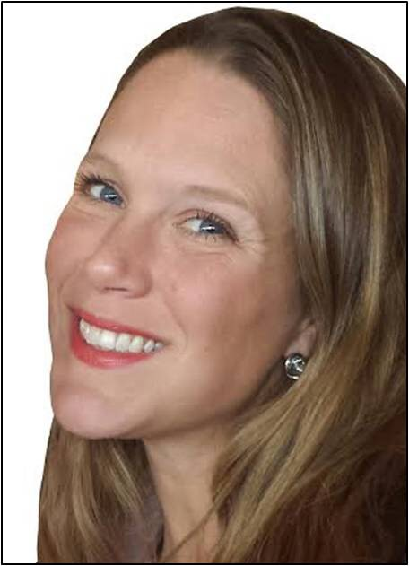

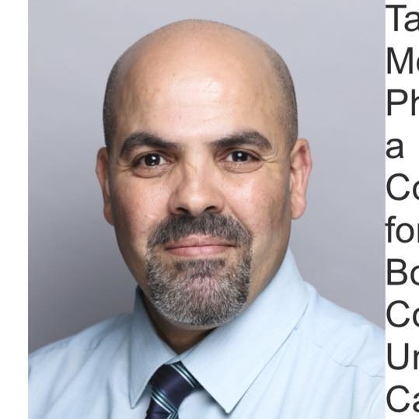
Taoufiq Cherkaoui- Presenter
Dubai British School
Coordinator of Arabic, Islamic and Social Studies
Education Consultant and Bilingual Trainer, Cambridge University CIE.
Principal Examiner, Edexcel Pearson.
Lead Practitioner of Arabic, French and Assessment for Learning.
Arabic Advisor to the British Council.

Taoufiq is a Lead Practitioner of modern languages and philosophy and religion. He is also a Language Advisor to the British Council and a Principal Examiner for Edexcel Pearson Exam Board.
Taoufiq also works as an Education Consultant for Cambridge University CIE. He joined Cambridge CIE in 2011 following over fifteen years working as an education practitioner in the UK, France and Morocco. As an Education Consultant he completed a number of training sessions for teachers, middle leaders and leaders in Kazakhstan, Mongolia and Egypt, on education strategy, curriculum development, summative and formative assessment, and item writing in languages.

Taoufiq often takes part in international seminars and conferences by presenting talks and running workshops relating to education strategy, assessment and teaching and learning. He has experience of curriculum and schemes of work development for languages through working with the British Council and Cambridge University CIE.
@DBS_Springs
www.arabalicious.com

Jonathan Price- Presenter
ETeach International
Recruitment Managing Director

Managing Director at Eteach International based in Dubai. Specialising in the placement of education professionals into International schools located around the globe. With an extensive background in international education and school leadership, Jonathan can bring a different perspective to education recruitment. Bespoke recruitment solutions mean that ETeach can work with schools and consult on their current recruitment policies, offering advice and guidance and demonstrating how we can engage and attract quality staff. As a school Principal, Jonathan was able to recruit quality teachers to work in the schools in which he operated. Now he has an opportunity to work with a multitude of international schools in their search for leaders and teachers.

@eteachintl
www.eteach.com/international/

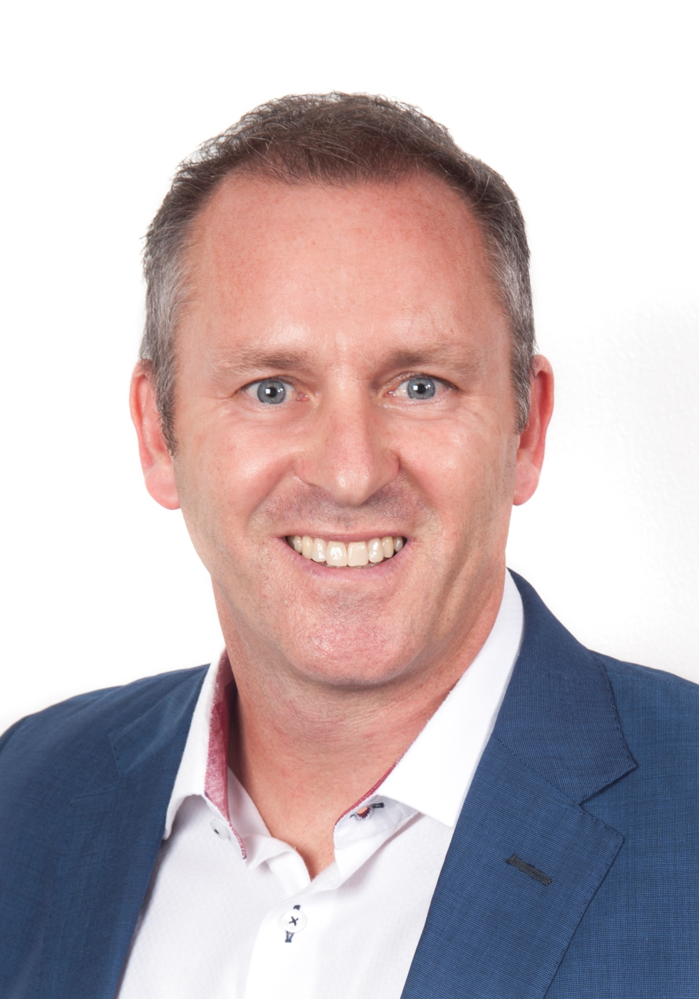


Neal Oates- Presenter
Dubai British School
Head of Primary computing

Neal became one of the lead coordinators for SPARK in 2014 having supported the SPARK team since arriving in Dubai in 2013. SPARK has had a huge impact upon Neal’s teaching and he has become an advocate for teacher led CPD and collaboration as a result. He gained his a degree in Business Management (2:1) at Aberystwyth University before embarking on a graduate program for 2 years in London at a leading ICT reseller. He subsequently decided that ICT sales was not his true passion and completed his PGCE at Nottingham Trent University in Business & Economics.
Neal was previously head of house at Dubai British School for 3 years and has a keen interest in the pastoral needs of students, especially when it comes to distributed student leadership and digital awareness. More recently Neal’s passion for technology has led to him to becoming the Head of Primary Computing at Dubai British School. He is a keen admirer of the “Lazy Teaching” approach and how technology can reduce teacher workloads whilst enhancing student progress and attainment. As of next year he will be joining the senior leadership team at DBS as the Head of Technology Integration.
@MrOatesSoSimple
www.dubaibritishschool.ae

Louise Dawson
Kings Al Barsha
Leader of Secondary Learning Support

Louise Dawson is the Leader of Secondary Learning Support at Kings’ School Al Barsha. As a new school this includes setting up the department from introducing Policy and Procedure through to the identification of students who need support, introducing support and intervention, exam access arrangements and the leadership of a team of Teachers and Support Assistants. Prior to Kings’, Louise spent three years at GEMS Wellington International School, and six years teaching in a mainstream school and a Special School in England. Prior to living in the UK, Louise spent eight years in Hong Kong.

After 20 years in Business, Louise trained to be a teacher as a mum of three, in her mid-thirties. Her interest in learning support started after her oldest son was identified with a dyspraxic and dyslexic profile. Dissatisfied with his support she became informed and subsequently retrained. After studying a degree in Education and becoming a qualified teacher, she completed her UK National Accreditation of Special Education Need Co-ordination. Louise has experienced the highs and lows of parenting children with need, as well as the highs and lows of teaching students with need.

@KingsAlBarsha
www.kingsdubai.com

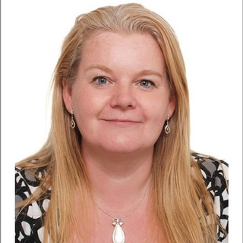

Running order
3.45pm- Sign in

4.00pm- Introductions Rachael Edgar

4.05pm- Opening keynote Ewan McIntosh

4.15pm- Presentations first half
Leading innovation in schools- Jim Stearns
Wellbeing- Michael Lambert
Professional Development- Deane Marwa
Leadership of Arabic and Islamic- Taoufiq Cherkaoui
Research and Development- Pearson

5.00pm- Break/Networking opportunity

5.20pm- Raffle- Presentations second half
SEND- Louise Dawson
Cyber Safety- Neal Oates
Every child needs a mentor- Harvey Trump
Assessment- Stephen Green
Attraction and retention- Jonathan Price

6pm onwards- You are invited to continue your discussions and
further explore presentation topics with the SPARK team at
McGettigans Dubai World Trade Centre

Sign up to host or attend a SPARK event at:
www.sparkevent.me

Contact: rachael@sparkevent.me

#SPARKevent 

