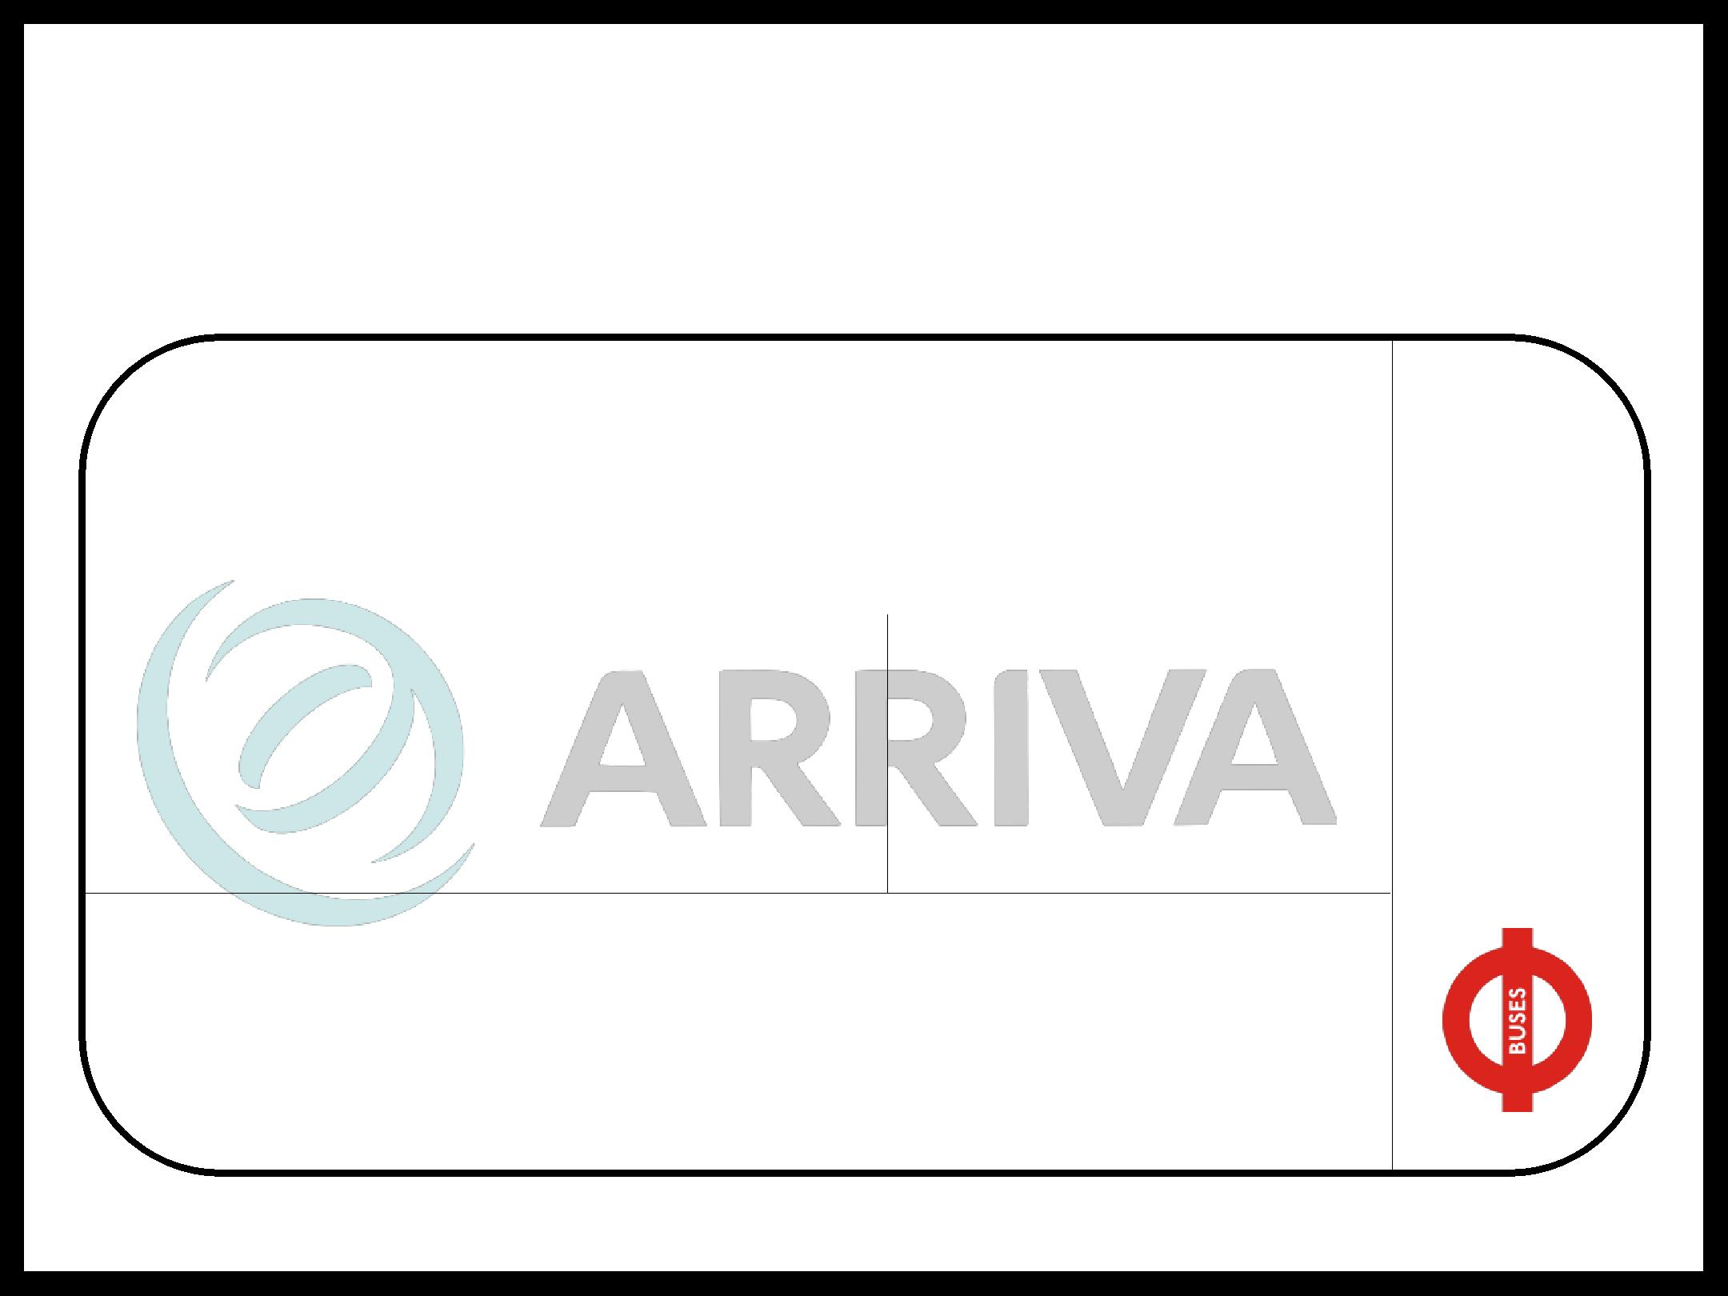
DESC TICKET TO RIDE!


Before we set off today, think back to your last lesson - what can you remember?

Title/focus of last lesson? | Any key words/terms/phrases that you remember?

Last lesson’s objectives | Any other comments?

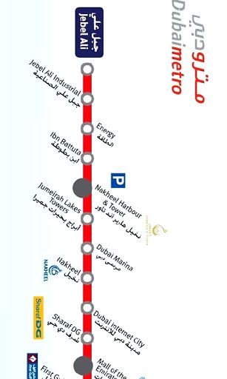

Can you sum up your learning from last lesson in a couple of sentences?

ONE WAY TICKET

