
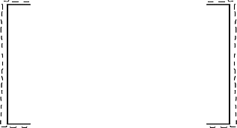


MARGINAL GAINS!

Dedicated Improvement and Reflection Time
Summarise your BUBBLE:
TASK:

DIRT PAGE
Summarise your BOX:

My response to feedback (mri):
Grade
Other
Redrafted Paragraph
‘SPaG’ Task
Response to teacher question
Additional Teacher Comments

