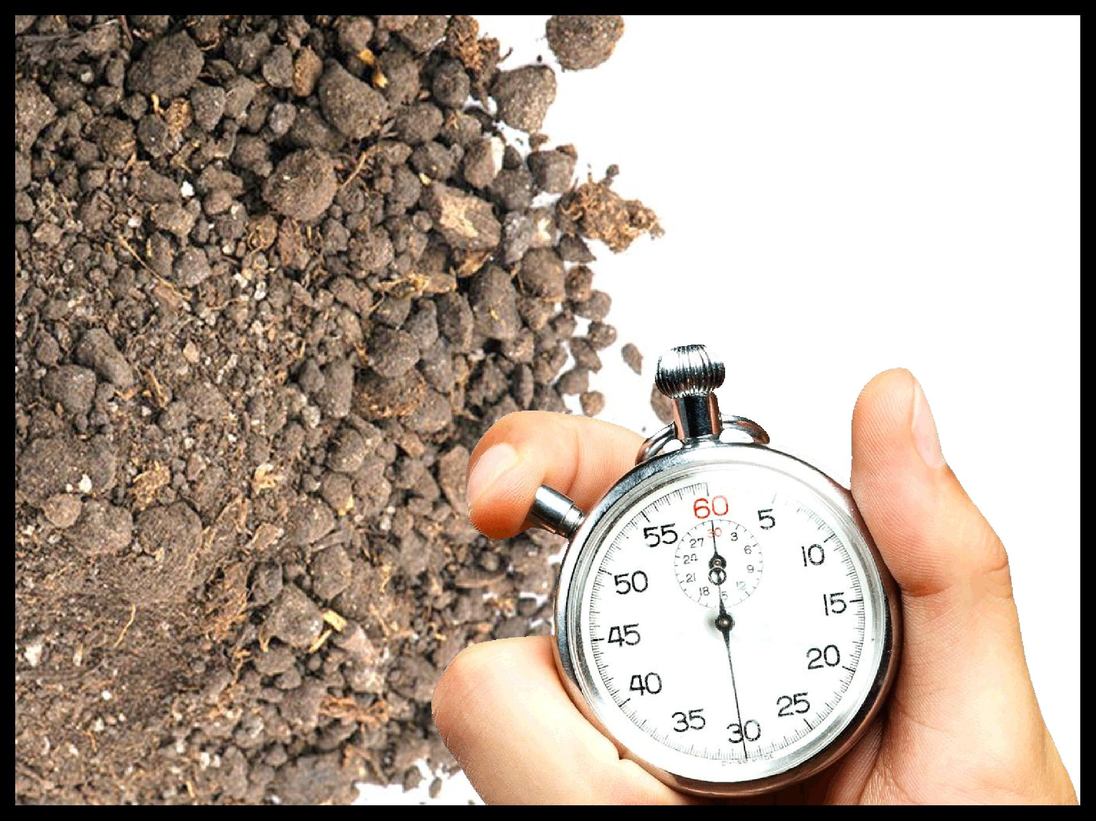
‘DIRT’
checklist

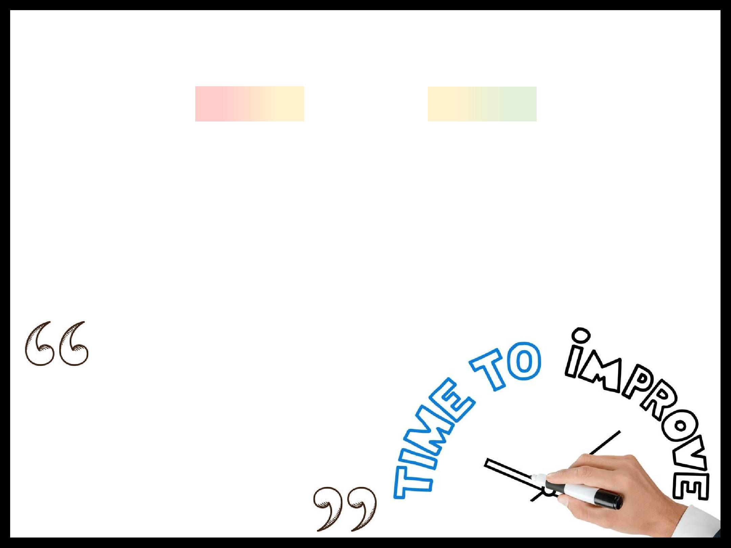
‘DIRT’ checklist

Directed Improvement and Reflection Time

1. Subject |  | 2. Literacy |  | 3. standards
Have I improved my |  | Have I corrected all |  | Have I tidied up my
work as directed by |  | my literacy errors? |  | book? Glued in loose
my teacher? Is there |  | (e.g. capital letters; |  | sheets? Underlined
anything else I could |  | punctuation; spelling; |  | headings and dates
improve or complete? |  | paragraphing) |  | neatly with a ruler?

You can learn a lot from your mistakes when you aren’t busy denying them.

Mistakes are the portals of discovery.

Practice the philosophy of continuous improvement. Get a little better every day.

There is always room for improvement.

Mistakes are the stepping stones to success.

