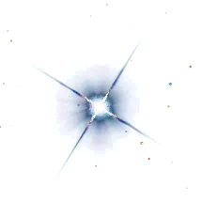

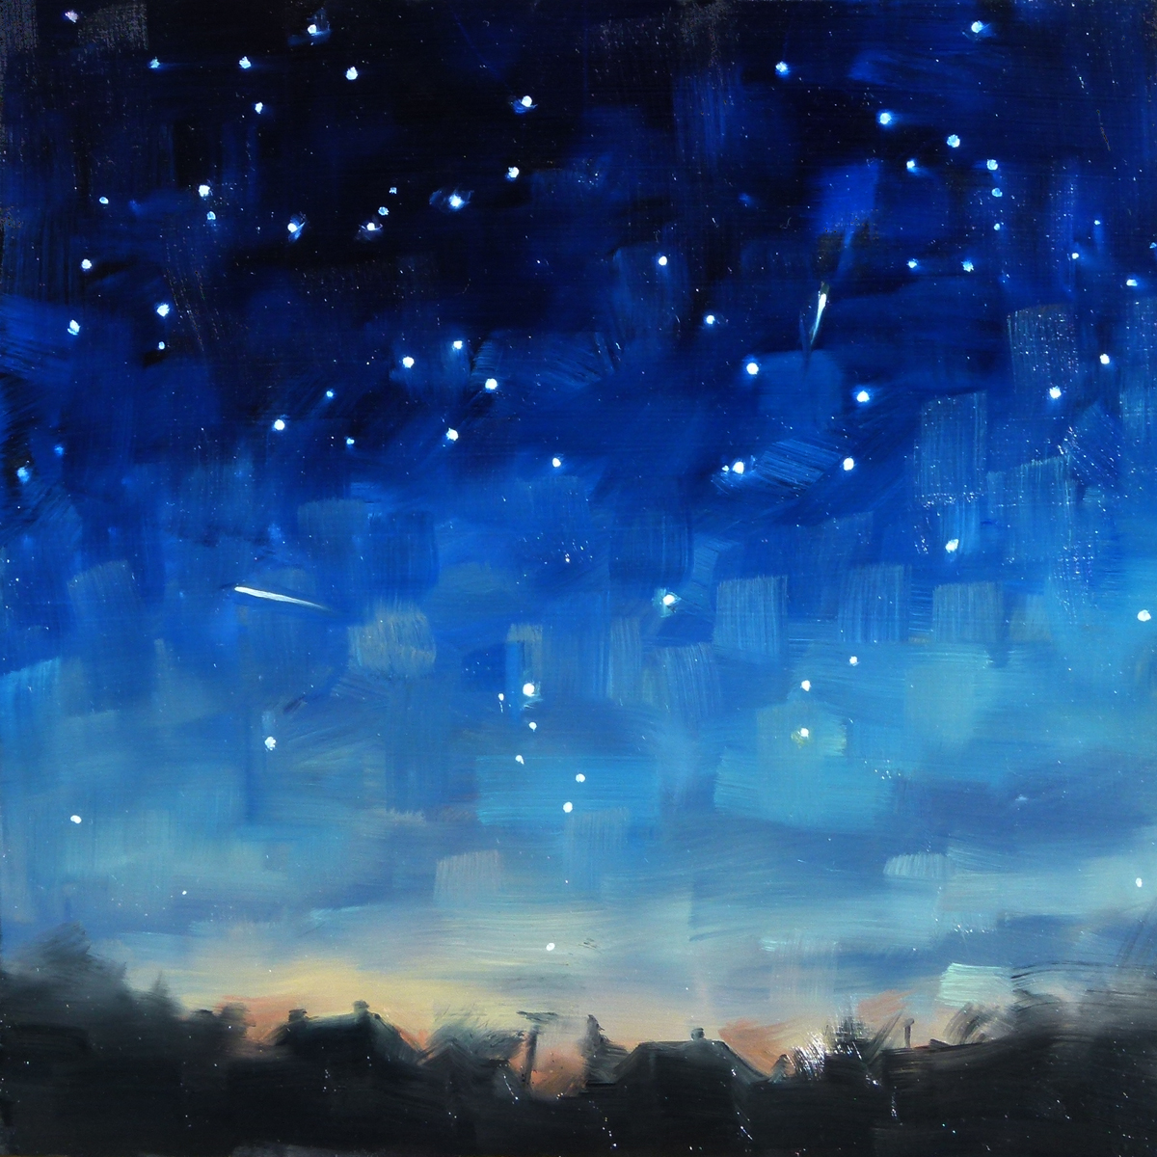
MAKE YOUR WORK TWINKLE WITH THESE A* TERMS
DECONSTRUCTION:
To Reduce (something) to its basic parts in order to reinterpret it..

PROLIFERATION:
Increase rapidly in number; multiply

SYMBIOTIC
RELATIONSHIP:
A relationship of mutual benefit or dependence.

MYRAID:
A countless or extremely great number of people or things.

JUXTAPOSITION:
two things being seen or placed close together with contrasting effect.

UBIQUITOUS:
Present, appearing, or found everywhere.

PARADOX:
A seemingly contradictory statement that may nonetheless be true (the paradox that standing is more tiring than walking)

EMANCIPATE:
Set free, especially from legal, social, or political restrictions
MALEVOLENCE
Intense often vicious ill will, malice, spite, or hatred

CONVENTIONAL:
Based on or in agreement with what is generally done or believed.

FRAGMENTED:
Broken into small pieces/fragments.

ANTITHESIS:
A person or thing that is the direct opposite of someone or something else.

RAMIFICATION:
A complex or unwanted consequence of an actions or events

AMBIVALENT:
mixed feelings or contradictory ideas about a character, something or someone.

PARADIGM:
A typical example or outline of something; a pattern or model.

VERISIMILITUDE:
The appearance of being true or real: (the detail gives the novel some verisimilitude)
PERIPHARY:
The outer limits or edge of a place, area or object.

TRANSIENT:
Lasting only for a short time; impermanent.

ANTAGONIST:
A character who deceives, frustrates, or works against the protagonist in some way.
MICROCOSM:
Something encapsulating in miniature the characteristics of something much larger.

PSEUDO:
A pretentious or insincere person; not genuine; a sham

INTRINSIC:
Something that is natural or inherent, as opposed to something that has to be learnt

PATHOS:
A quality that evokes pity, tenderness or sadness.

ARBITRARY:
Random choice or personal whim, rather than any reason or system.

DICHOTOMY:
a division or contrast between two things that are or are represented as being opposed or entirely different.

STAR WORDS

